**ABSTRACT**

The communication gap between the police and the citizens of the country are a direct result of our diversity of language and geography. This has led to citizens not able to reach the police for their needs and the police not able to provide services effectively. The law enforcement authorities have limited resources for coordinating their services and helping the need in time and even enforcing the laws and preventing and minimizing crimes.

It provides two separate logins for the police and the citizens with different features for each.

**Flow chart**

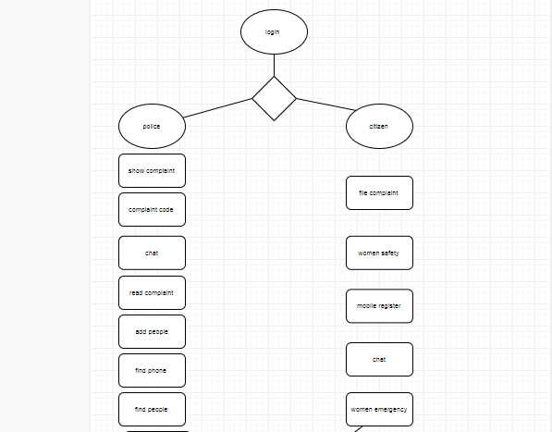

PolicetoCitizen is a mobile application on Android platform to help the people in emergencies situation by allowing them to report a crime, physical emergencies, and provide a common application for all the police operations in a country by removing the language barriers.

This allows a common gate way for the police to maintain all the records and coordinate their work in a structured manner. The feature available for this login are.

* Complaint Registration(Through the QR codes)
* Getting IMEI of registered mobile phone
* Vehicle Details using vehicle number
* SMS Notification for popularizing
* Women Safety and tracking
* Chatting with citizens to provide guidance

The citizens are able to effectively communicate with authorities and get tier assistance .the facilities provided for them are.

* Complaint Registration with location
* Women Emergency through widgets
* Chatting with police for assistance
* Helpline numbers
* Fine payment with QR codes

This application uses firebase real time database for data analysis. Third party API’s for QR code generation, image processing, chatting. It is built on Android Studio platform and is supported for all android devices and only have basic requirements like Internet,

The main perks of this application are it reduces the geographical boundaries between the police and the people. It allows adaptive decision making by the police and making them a approachable service. The people can enjoy the benefits of police in ease and allowing them to get help in all cases if they have their mobile phone

**Screen shots:-**

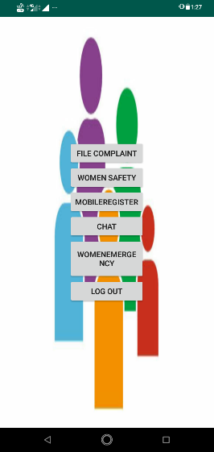 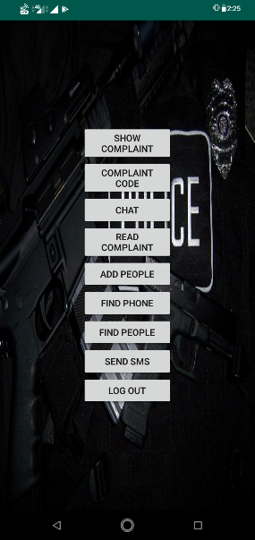

Citizen login -where provides of citizen login Police login

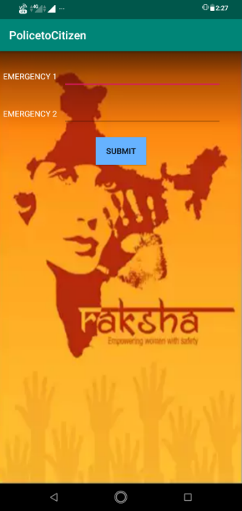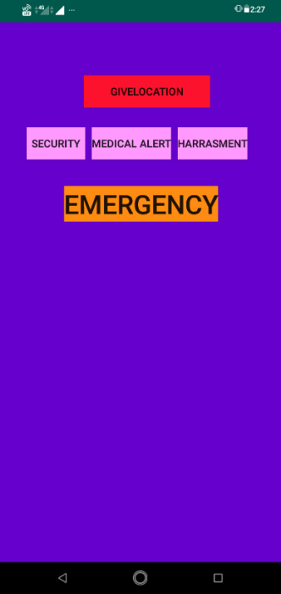 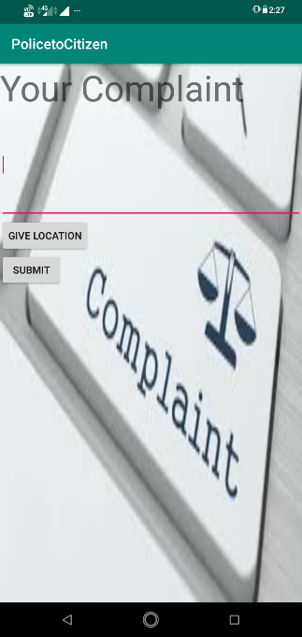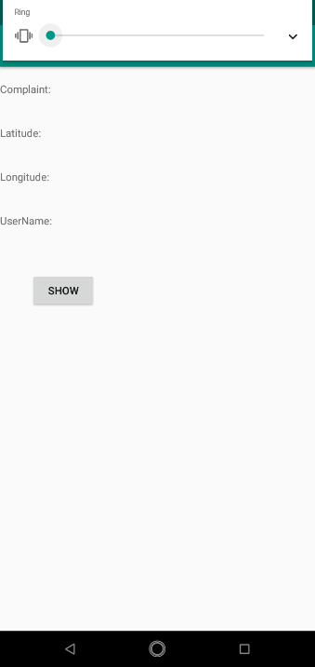

Women Safety Filling and Showing Complaint